Cargomatic Service Documentation

**Overview:** Cargomatic is a technology company based in Venice Beach, CA. PayAirCargo platform is born for passion to solve the inefficiency and fragmentation of the local trucking industry. Simply, we connect shippers with qualified carriers who have unutilized capacity on their trucks.

**How Do We Connect You:**

* Step 1 – Log in to our website [www.payaircargo.com](http://www.payaircargo.com).

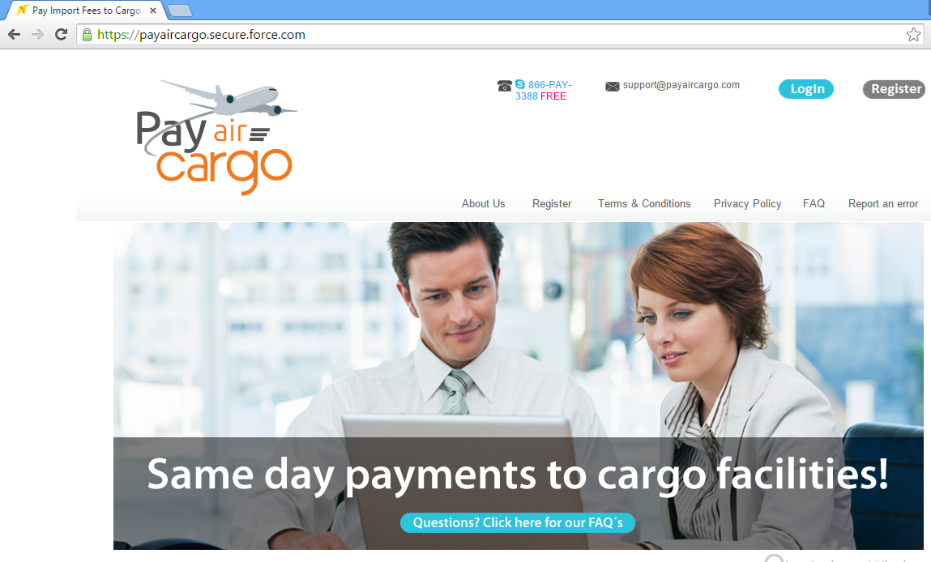

* Step 2 – Create a valid login / register Customer.
* Step 3 – Open tab “New Facility Payment / Contacts”.

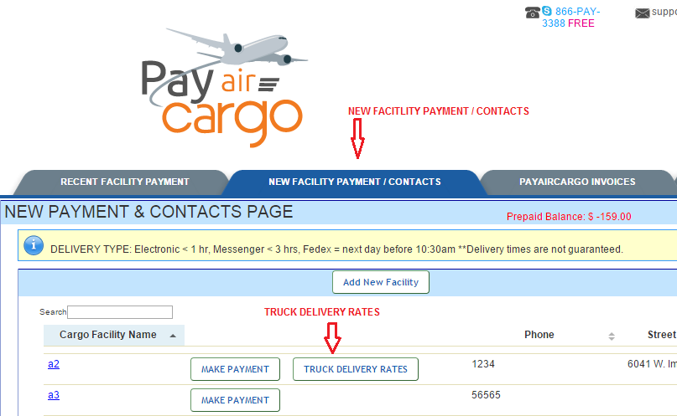

* Step 4 – Click on the “Truck Delivery Rates” Button.

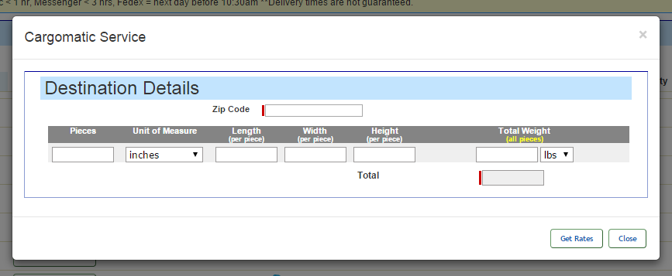

* Step 5 – Fill the required fields on boxes. Click on Get Rates.
* Step 6 – Following List will display your carrier charges.

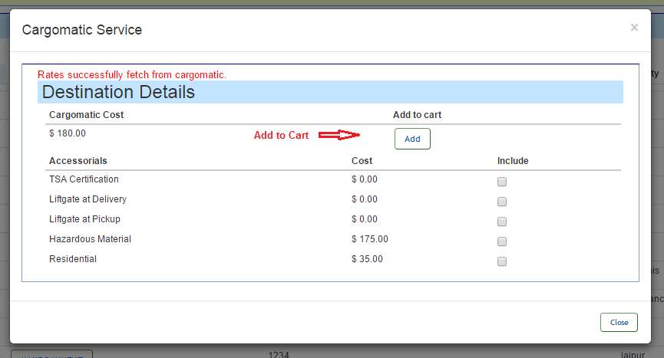

* Step 7 - Click on “Add to Cart” Button for add Source and Destination.

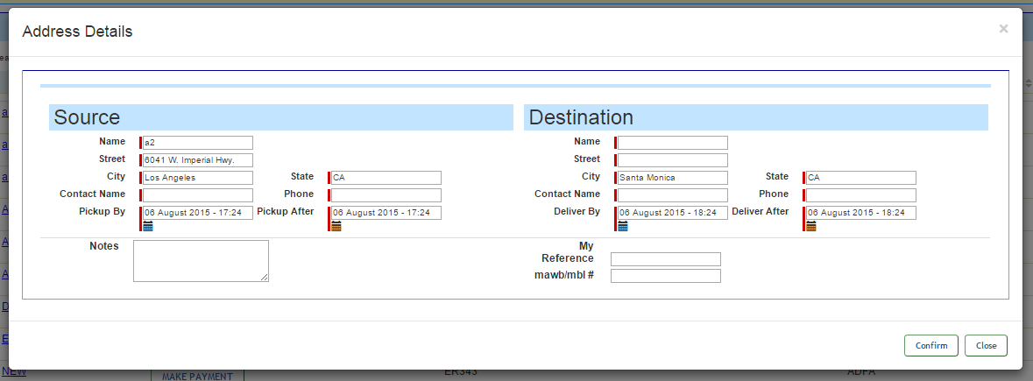

* Step 8 – Click on “Print BOL” Button to generate cargomatic shipment details.

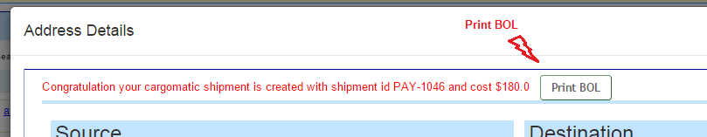

Hear your PDF will be generated with details from Cargomatic Service.

